

**Lab 8**

**AIPM**

Fake News Detection

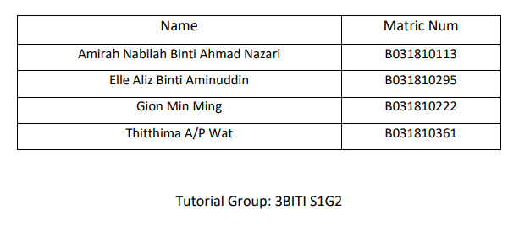

**Lab 8- AOA & AON NETWORK**

1. **Given below is a Table WBS of RAMOV Project.**

**Based on your proposed AIProject, draw your Gantt chart with your timeline, milestone and description as given example at the Figure 1.**

* **The Gantt charts should provide a standard format for displaying project schedule information by listing project activities and their corresponding start and finish dates in a calendar format include following Symbols:**
  + **Black diamonds: Milestones**
  + **Thick black bars: Summary tasks**
  + **Lighter horizontal bars: Durations of tasks**
  + **Arrows: Dependencies between tasks**

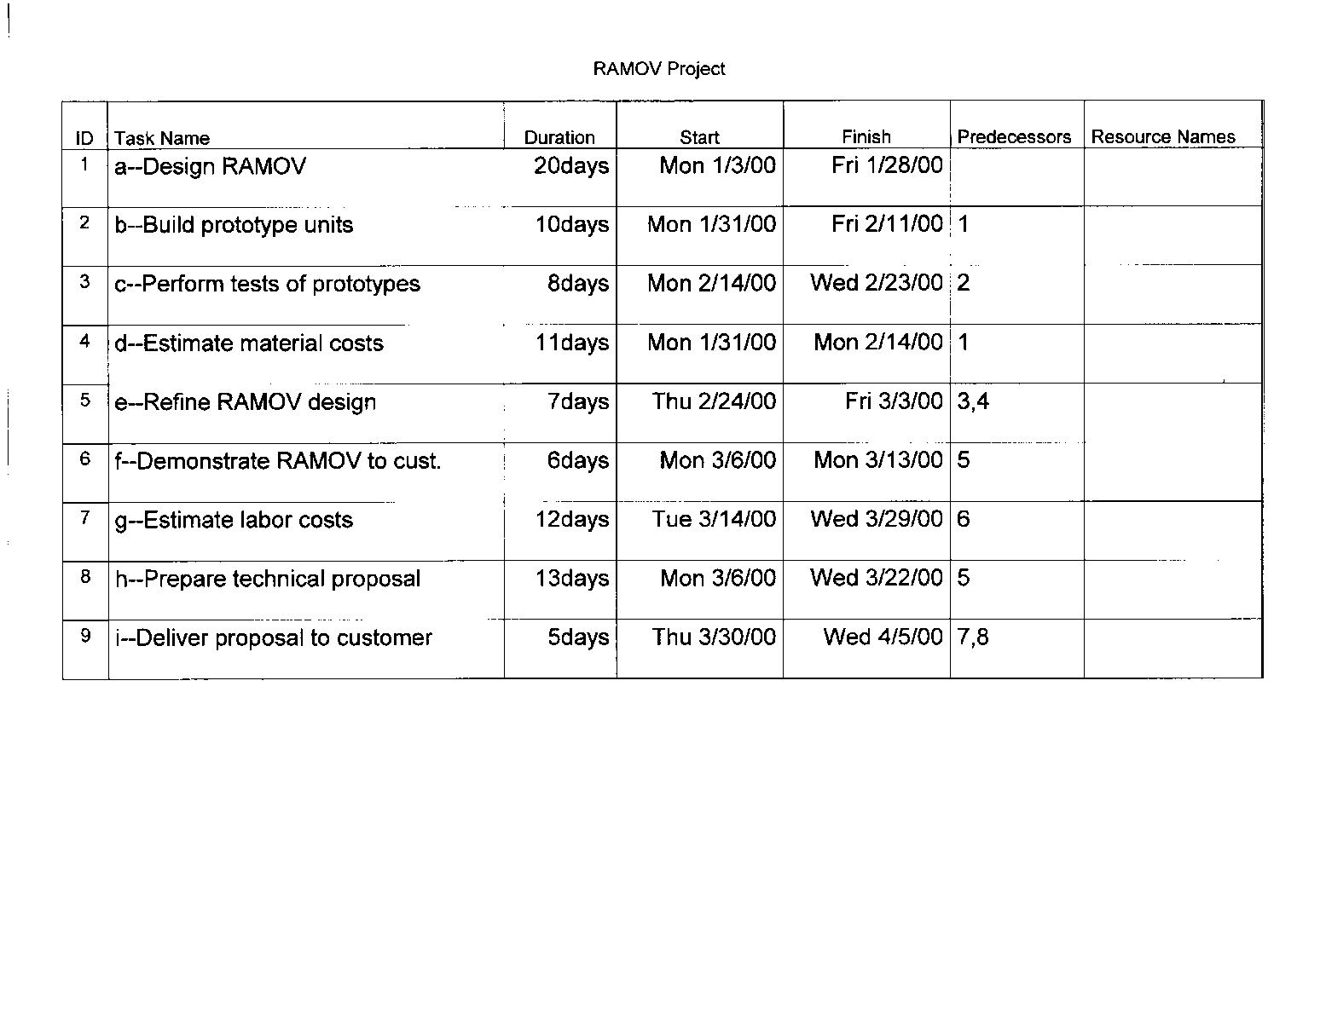

**Figure 1: RAMOV Project**

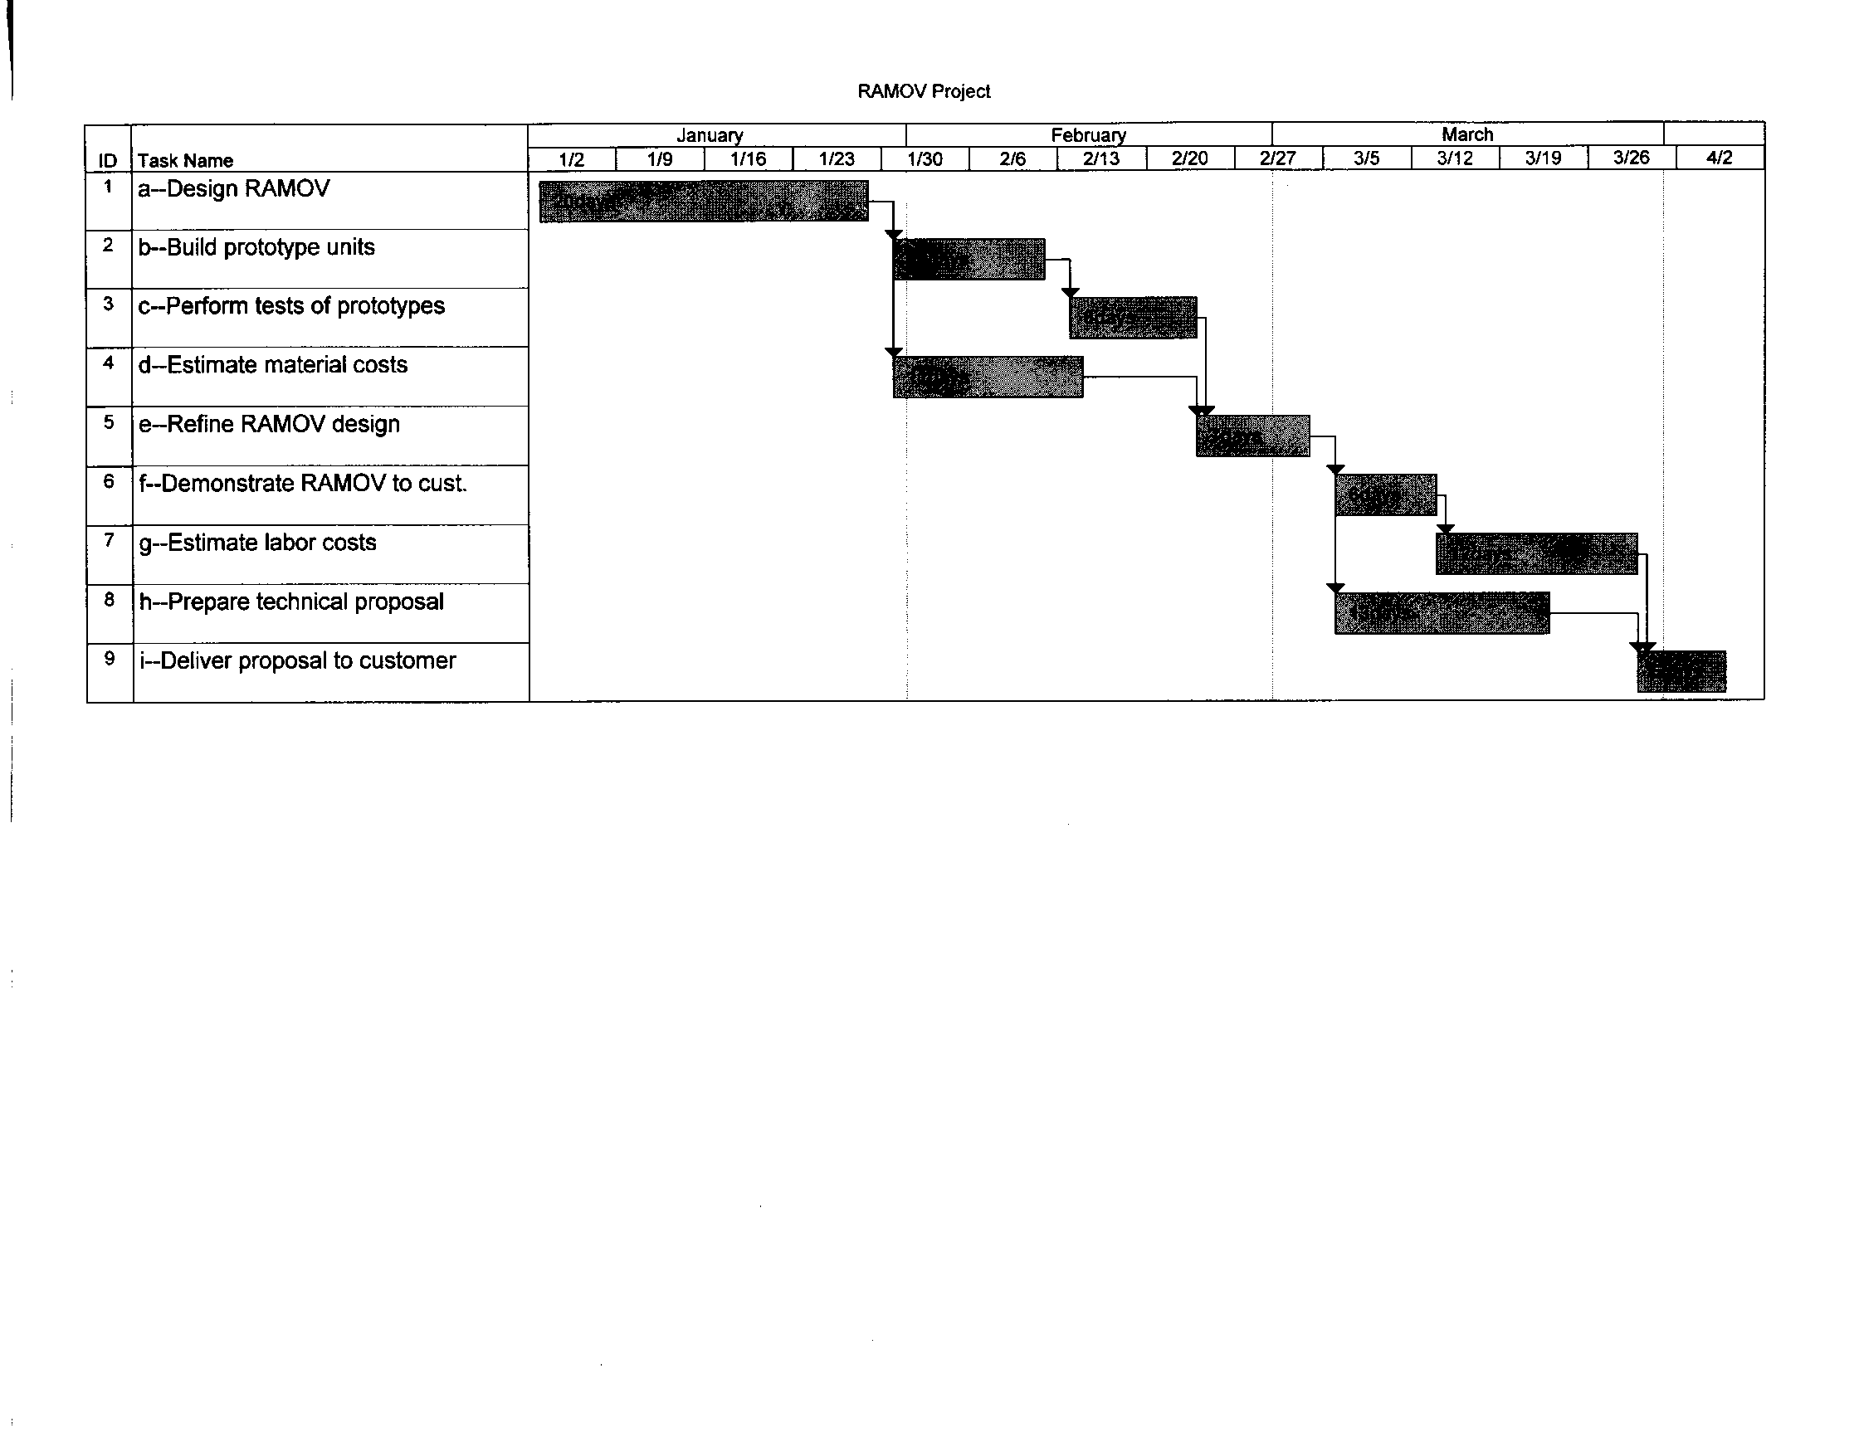**Sample Gantt Chart**

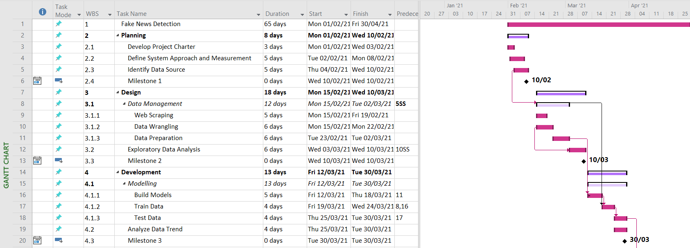 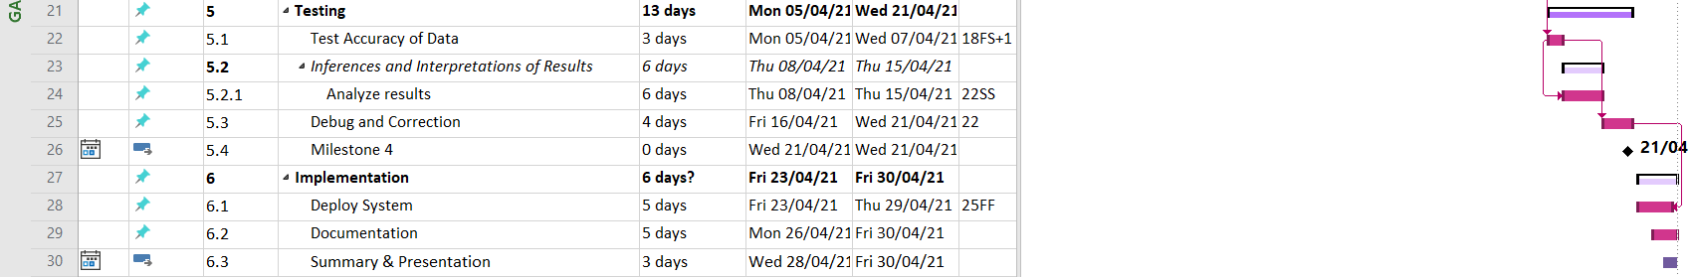

Milestones:

Summary task: 

Duration of tasks: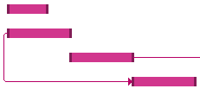

Dependencies between tasks: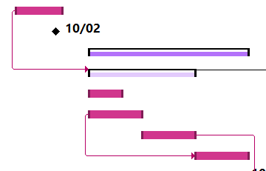

1. **Identify each path for FTMK Artificial Intelligence Project in Figure 1 and determine the *Critical Path* for AIFTMK Project.**

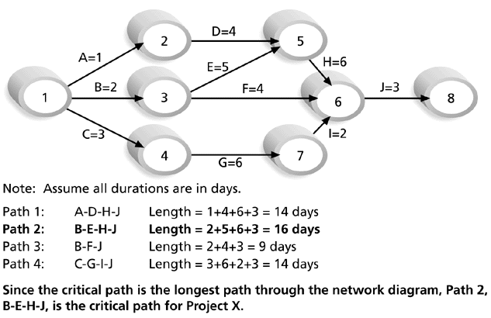

**Note: Assume all durations are in days.**

**Figure 2: FTMK AI Project**

Solution :-

i. Path 1

A,D,H,J = 1 + 4 + 6 + 3

= 14 days

ii. Path 2

B,E,H,J = 2 + 5 + 6 + 3

= 16 days

iii. Path 3

B,F,J = 2 + 4 + 3

= 9 days

iv. Path 4

C,G,I,J = 3 + 6 + 2 + 3

= 14 days

To conclude, the critical path for this FTMK AI project network diagram is on path 2, which is B-E-H-J = 16 days.